Batch: A2 Roll No.: 16010122034

Experiment No. 06

Grade: AA / AB / BB / BC / CC / CD /DD

Title: Implementation of Linked List

Objective: To understand the use of linked list as data structures for various application.

Expected Outcome of Experiment:

CO | Outcome
CO 2 | Apply linear and non-linear data structure in application development.

Books/ Journals/ Websites referred:

Introduction:
Define Linked List
A linked list is a data structure used in computer science to organize and store a collection of elements, called nodes, in a linear order. Each node in a linked list contains two parts:
- Data: This part holds the actual element or value being stored in the list.
- Pointer (or reference): This part points to the next node in the sequence, creating a connection between nodes.
The first node in the list is called the "head," and the last node typically points to a null reference, indicating the end of the list. Linked lists provide flexibility in adding or removing elements, making them suitable for dynamic data structures.
Types of linked list:
Different Types of Linked Lists:
1. Singly Linked List:
In a singly linked list, each node points to the next node in the sequence. It is the simplest form of a linked list.Traversal is one-way, from the head to the end. Commonly used for implementing stacks and queues.
2. Doubly Linked List:
In a doubly linked list, each node points to both the next and the previous nodes in the sequence. Allows for bidirectional traversal, making it more efficient for certain operations. Often used in implementations requiring insertion or deletion from both ends.
3. Circular Linked List:
A circular linked list is a variation of a singly or doubly linked list where the last node points back to the first node, creating a loop. Useful for applications like a circular buffer or representing cyclical data.
4. Skip List:
A skip list is a data structure that uses multiple linked lists with different levels of granularity. Allows for efficient searching, insertion, and deletion of elements, similar to a balanced tree but with simpler implementation.
Each type of linked list has its advantages and is chosen based on specific requirements and use cases in different applications.
Algorithm for creation, insertion, deletion, traversal and searching an element in assigned linked list type:
1. Creating a Doubly Linked List:
Algorithm CreateDoublyLinkedList():
Input: None
Output: A new empty doubly linked list
1. Create a pointer "head" and set it to NULL.
2. Return the "head" as the new doubly linked list.

2. Inserting a Node at the Beginning:
Algorithm InsertAtBeginning(head, data):
Input: A pointer to the head of the doubly linked list, and the data to be inserted.
Output: Updated doubly linked list with the new node at the beginning.
1. Create a new node "newNode" with the given data.
2. Set newNode's next pointer to the current head.
3. If the current head is not NULL, set the previous pointer of the current head to newNode.
4. Set head to newNode.
5. Return the updated head.

3. Inserting a Node at the End:
Algorithm InsertAtEnd(head, data):
Input: A pointer to the head of the doubly linked list, and the data to be inserted.
Output: Updated doubly linked list with the new node at the end.

1. Create a new node "newNode" with the given data.
2. If the list is empty (head is NULL), set head to newNode.
3. Otherwise, traverse the list to find the last node.
4. Set the next pointer of the last node to newNode.
5. Set the previous pointer of newNode to the last node.
6. Return the head.

4. Deleting a Node at the Beginning:
Algorithm DeleteAtBeginning(head):
Input: A pointer to the head of the doubly linked list.
Output: Updated doubly linked list with the first node removed.
1. If the list is empty (head is NULL), return NULL.
2. If head has a next node, set the previous pointer of the next node to NULL.
3. Set head to head's next node.
4. Return the updated head.

5. Deleting a Node at the End:
Algorithm DeleteAtEnd(head):
Input: A pointer to the head of the doubly linked list.
Output: Updated doubly linked list with the last node removed.
1. If the list is empty (head is NULL), return NULL.
2. If there is only one node in the list (head's next is NULL), set head to NULL and return NULL.
3. Traverse the list to find the last node.
4. Set the next pointer of the second-to-last node to NULL.
5. Return the head.

6. Traversing the Doubly Linked List:
Algorithm TraverseDoublyLinkedList(head):
Input: A pointer to the head of the doubly linked list.
Output: Display the elements of the doubly linked list.
1. Initialize a pointer "current" to the head of the list.
2. While current is not NULL:
a. Display the data of the current node.
b. Move current to the next node.
3. End.

7. Searching for an Element:
Algorithm SearchElement(head, target):
Input: A pointer to the head of the doubly linked list and the target element to search for.
Output: Return the node containing the target element if found; otherwise, return NULL.
1. Initialize a pointer "current" to the head of the list.
2. While current is not NULL:
a. If the data in the current node matches the target, return the current node.
b. Move current to the next node.
3. Return NULL (element not found).

Implementation of an application using linked list:
#include <stdio.h>
#include <stdlib.h>

struct Node {
int data;
struct Node* next;
};

struct Node* createNode(int data){
struct Node* newNode = (struct Node*)malloc(sizeof(struct Node));
newNode->data = data;
newNode->next = NULL;
return newNode;
}

struct Node* insertAtStart(struct Node* head, int data){
struct Node* newNode = createNode(data);
newNode->next = head;
return newNode;
}

struct Node* insertAtPosition(struct Node* head, int data, int position){
struct Node* newNode = createNode(data);
if (position == 1){
newNode->next = head;
return newNode;
}
struct Node* current = head;
for(int i = 1; i < position - 1 && current != NULL; i++){
current = current->next;
}
if (current == NULL){
printf("Position out of range.\n");
free(newNode);
return head;
}
newNode->next = current->next;
current->next = newNode;
return head;
}

struct Node* insertAtEnd(struct Node* head, int data){
struct Node* newNode = createNode(data);
if(head == NULL){
return newNode;
}
struct Node* current = head;
while(current->next != NULL){
current = current->next;
}
current->next = newNode;
return head;
}

struct Node* deleteAtStart(struct Node* head){
if(head == NULL){
printf("Linked list is empty.\n");
return NULL;
}
struct Node* temp = head;
head = head->next;
free(temp);
return head;
}

struct Node* deleteAtPosition(struct Node* head, int position){
if(head==NULL){
printf("Linked list is empty.\n");
return NULL;
}
if(position == 1){
struct Node* temp = head;
head = head->next;
free(temp);
return head;
}
struct Node* current = head;
struct Node* previous = NULL;
for(int i = 1; i< position && current != NULL; i++){
previous = current;
current = current->next;
}
if(current == NULL){
printf("Position out of range.\n");
return head;
}
previous->next = current->next;
free(current);
return head;
}

struct Node* deleteAtEnd(struct Node* head){
if(head == NULL){
printf("Linked list is empty.\n");
return NULL;
}
if(head->next == NULL){
free(head);
return NULL;
}
struct Node* current = head;
struct Node* previous = NULL;
while(current->next != NULL){
previous = current;
current = current->next;
}
previous->next = NULL;
free(current);
return head;
}

void display(struct Node* head){
struct Node* current = head;
while(current != NULL){
printf("%d -> ", current->data);
current = current->next;
}
printf("NULL\n");
}

int main(){
struct Node* head = NULL;
int choice, data, position, numElements;

printf("Enter the number of elements in the linked list: ");
scanf("%d", &numElements);

printf("Enter the elements:\n");
for(int i = 0; i < numElements; i++){
scanf("%d", &data);
head = insertAtEnd(head, data);
}

do{
printf("\n1. Insert at the beginning");
printf("\n2. Insert at a specified position");
printf("\n3. Insert at the end");
printf("\n4. Delete from the beginning");
printf("\n5. Delete from a specified position");
printf("\n6. Delete from the end");
printf("\n7. Display");
printf("\n8. Exit");
printf("\nEnter your choice: ");
scanf("%d", &choice);

switch(choice){
case 1:
printf("Enter data: ");
scanf("%d", &data);
head = insertAtStart(head, data);
break;
case 2:
printf("Enter data: ");
scanf("%d", &data);
printf("Enter position: ");
scanf("%d", &position);
head = insertAtPosition(head, data, position);
break;
case 3:
printf("Enter data: ");
scanf("%d", &data);
head = insertAtEnd(head, data);
break;
case 4:
head = deleteAtStart(head);
break;
case 5:
printf("Enter position: ");
scanf("%d", &position);
head = deleteAtPosition(head, position);
break;
case 6:
head = deleteAtEnd(head);
break;
case 7:
display(head);
break;
case 8:
printf("Exiting...\n");
break;
default:
printf("Invalid choice.\n");
}
}while(choice != 8);

return 0;
}

OUTPUT
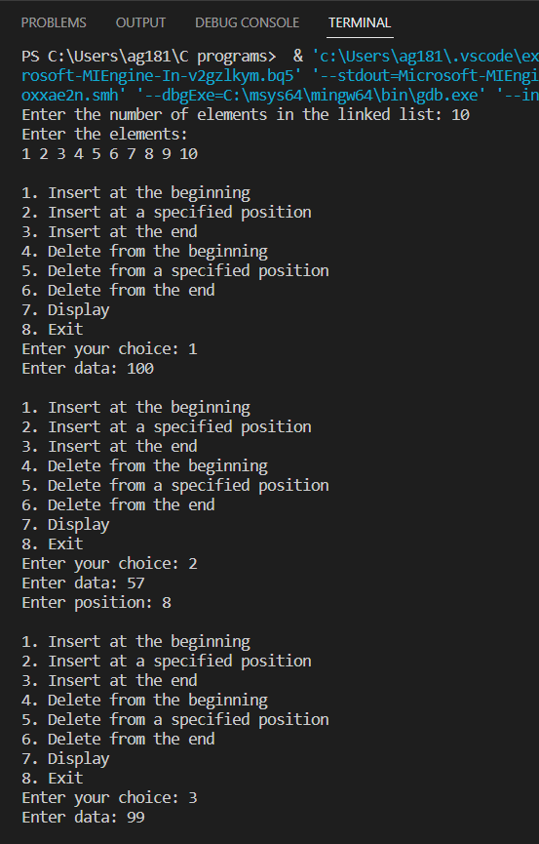

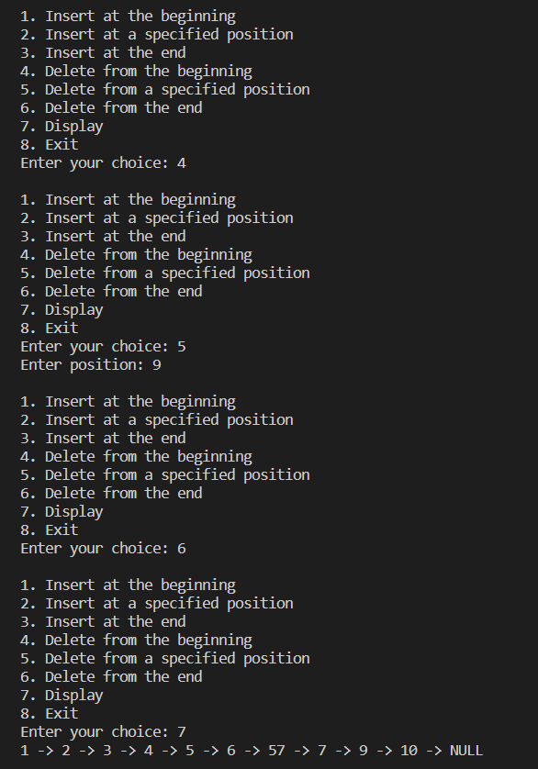
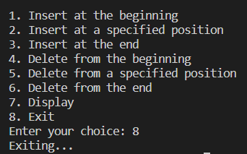
IMPLEMENTATION OF DOUBLY LINKED LIST: (CODE)
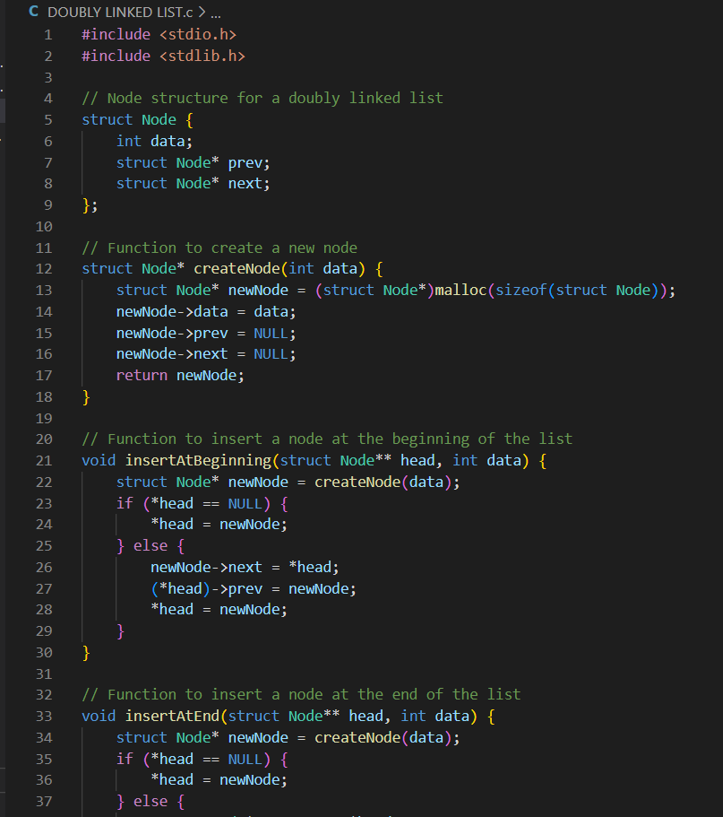
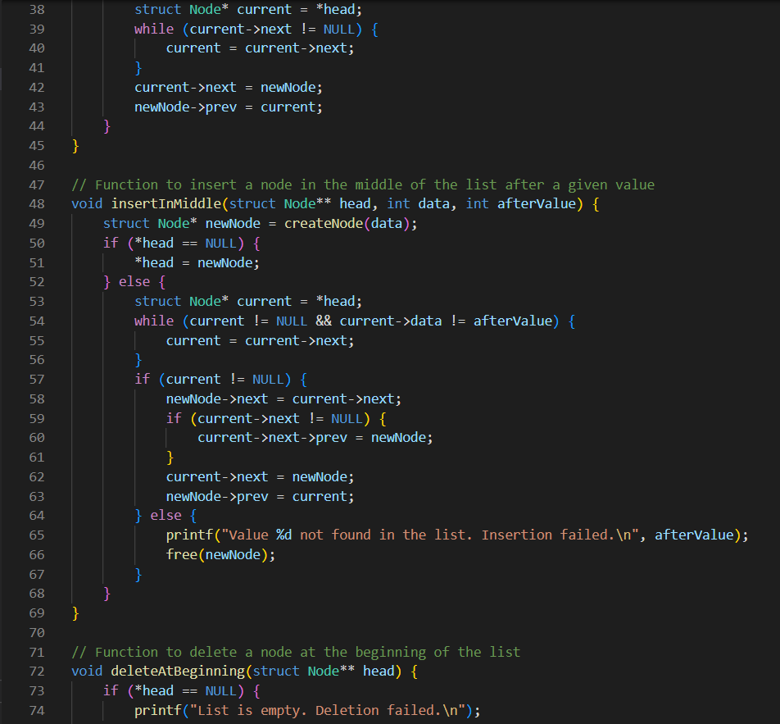
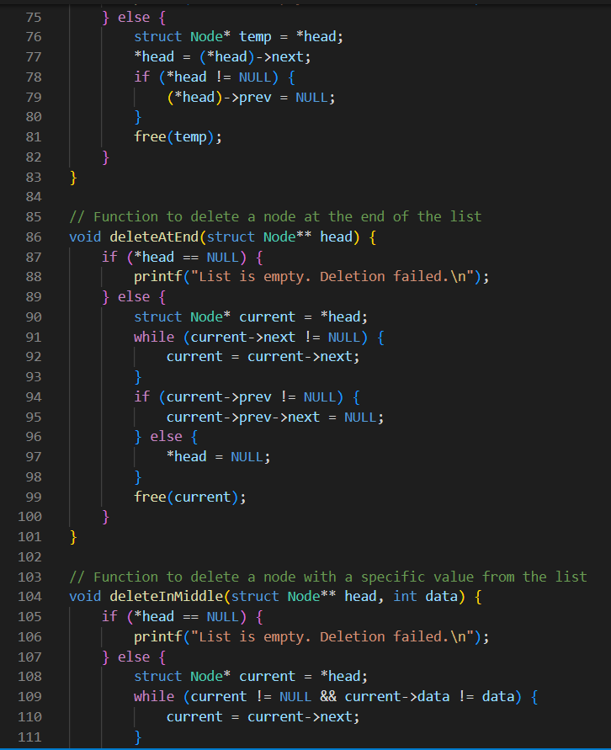

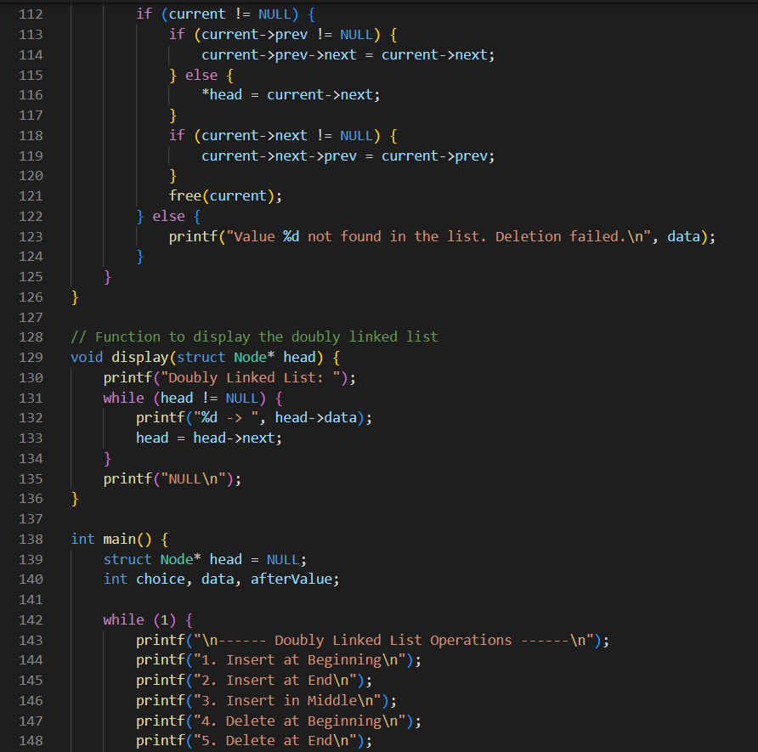

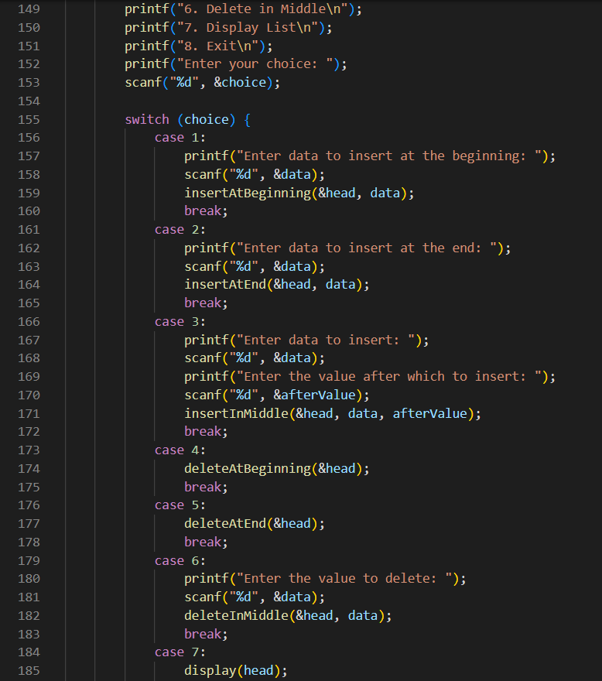
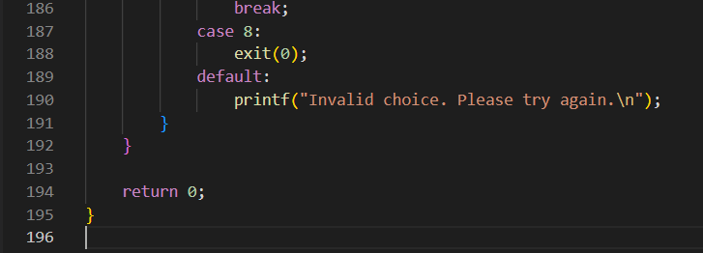

OUTPUT
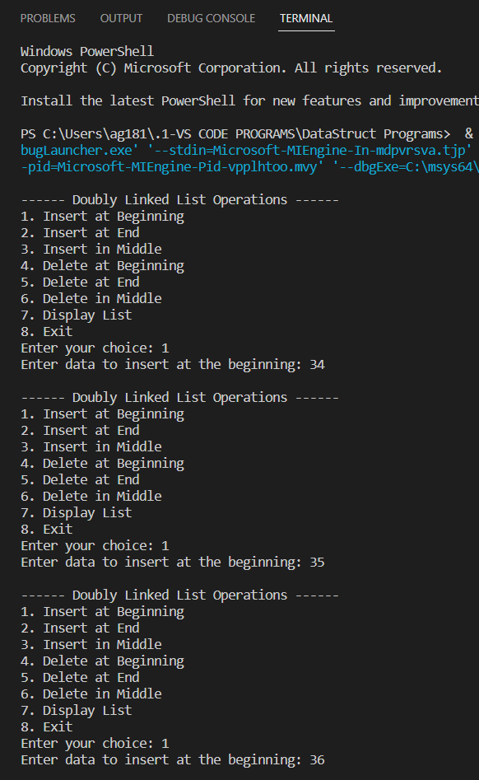

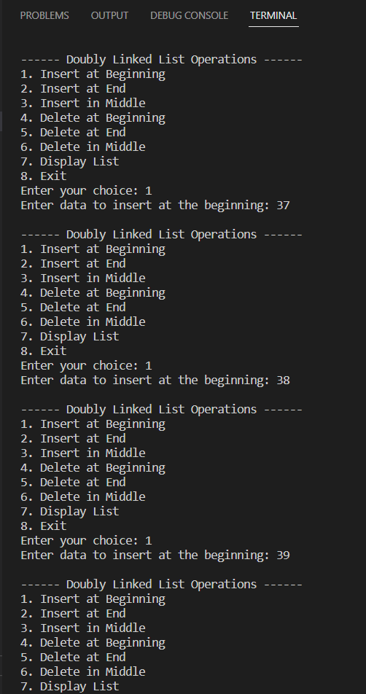
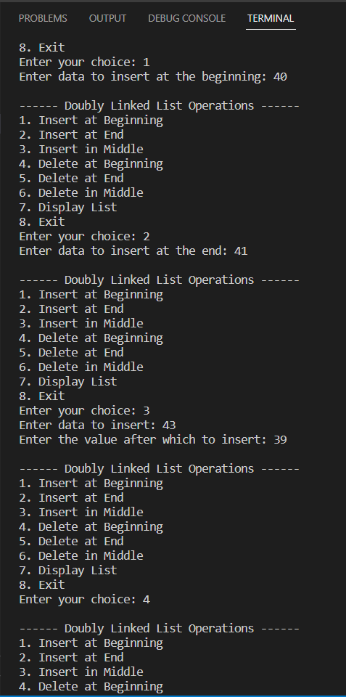
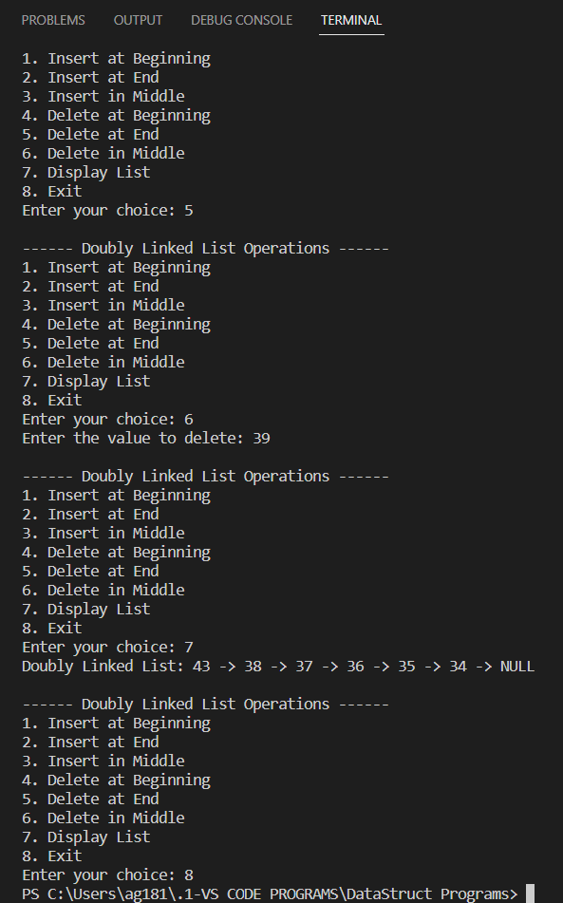

Conclusion:
Hence the implementation of various operations of doubly linked list was learnt and performed accordingly
Post lab questions:
1. Compare and contrast SLL and DLL
Singly linked list (SLL) | Doubly linked list (DLL)
SLL nodes contains 2 field -data field and next link field. | DLL nodes contains 3 fields -data field, a previous link field and a next link field.
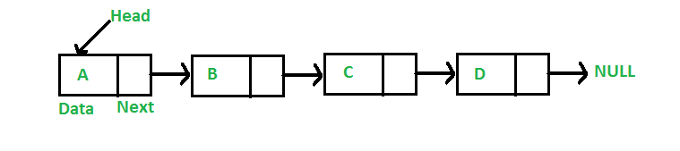 | 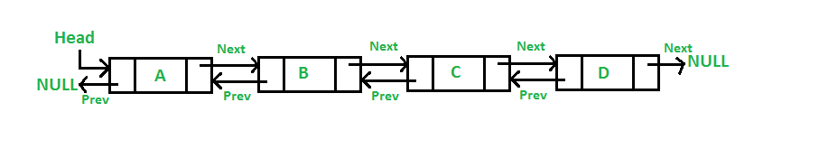
In SLL, the traversal can be done using the next node link only. Thus traversal is possible in one direction only. | In DLL, the traversal can be done using the previous node link or the next node link. Thus traversal is possible in both directions (forward and backward).
The SLL occupies less memory than DLL as it has only 2 fields. | The DLL occupies more memory than SLL as it has 3 fields.
Complexity of insertion and deletion at a given position is O(n). | Complexity of insertion and deletion at a given position is O(n / 2) = O(n) because traversal can be made from start or from the end.
Complexity of deletion with a given node is O(n), because the previous node needs to be known, and traversal takes O(n) | Complexity of deletion with a given node is O(1) because the previous node can be accessed easily
We mostly prefer to use singly linked list for the execution of stacks. | We can use a doubly linked list to execute heaps and stacks, binary trees.
When we do not need to perform any searching operation and we want to save memory, we prefer a singly linked list. | In case of better implementation, while searching, we prefer to use doubly linked list.
A singly linked list consumes less memory as compared to the doubly linked list. | The doubly linked list consumes more memory as compared to the singly linked list.
Singly linked list is less efficient.  It is preferred when we need to save memory and searching is not required as pointer of single index is stored. | Doubly linked list is more efficient.  When memory is not the problem and we need better performance while searching, we use doubly linked list.

